Recycling 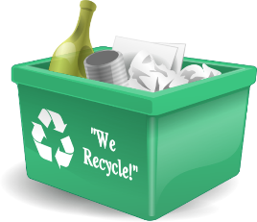
Dear Families,
Our class is going to be doing an activity about recycling. Please send in five items with your child that could be recycled. Please make sure that they’re not too big and are cleaned out if necessary. Please send the items in by Monday, March 13th.
Thank you,
Mrs. Bisker
Recycling
Dear Families, Our class is going to be doing an activity about recycling. Please send in five items with your child that could be recycled. Please make sure that they’re not too big and are cleaned out if necessary. Please send the items in by Monday, March 13th.
Thank you,
Mrs. Bisker

