Dave Harris, Principal
Renee Hall, Assistant Principal
SKIPPER
Fruitland Primary School

February 2017

Message from the Principal
TEACHER OF
THE YEAR NOMINATIONS

We are so fortunate to have an entire staff of highly qualified educators at Fruitland Primary who are committed daily to the academic excellence of each of our students. Congratulations to the following teachers for being nominated for Wicomico County Teacher of the Year.
Linda Dashiell (Kindergarten)
Sheree Draucker (Media)
Jessica Hanes (Kindergarten)
Phoebe Horsman (Grade 2)
Dana Lynerd (Grade 1)
Laurie Kamps (Kindergarten)
Shayn Smith (Art)

Our Fruitland Primary Finalist will be announced this week through the school Facebook page. Stay Tuned!

The month of February marks the beginning of the third marking period. It is during this marking period that our students and parents often observe that the daily curriculum becomes more rigorous as we as educators prepare our students for their next grade level. During the month, students in first and second grade will complete the county interim assessments in both reading and math. Student performance data from these assessments will drive instructional decisions at FPS in the months ahead. Although we do not automatically share individual student performance on our interim assessments, scores are available upon parental request. Please contact your child’s classroom teacher or a school administrator in early March if you are interested in hearing a detailed report about how your child performed on these county assessments.

Dave Harris
Principal

DR. SEUSS WEEK
February 27th to March 3rd

Monday, 2/27 – Mixed-Matched Shoe Day from The Foot Bank
Tuesday, 2/28 – Twin Day from
Thing 1 and 2 from The Cat in the Hat
Wednesday, 3/1 – Favorite Hat Day from
The 500 Hats of Bartholomew Cubbins
Thursday, 3/2 – Favorite Stuffed Animal Day from
If I Ran the Zoo
Friday, 3/3 – Seuss Character Dress Up Day – Guest readers will visit all classes

Like us on
Facebook
301 N. Division Street, Fruitland, MD 21826 410-677-5171 fps.wcboe.org
Important February Dates

February 1 – Report Cards Go Home
February 1 – 5-8 PM McDonald’s Spirit Night
February 6 – PTA Gertrude Hawk Fundraiser Begins (Materials will go home with students)
February 7 – Max Bent Beatboxing Assembly (All grades)
February 8 – 9:30 AM - Energy Assembly (Grade 2)
February 13 – 6:30 PM PTA / Multicultural Night at FIS
February 15 & 16 – Reading Interim Assessment (Grades 1 and 2)
February 16 – Parent University: Understanding PARCC at Wicomico Public Library
February 17 – Jump Rope for Heart Day
Upcoming Dates
March 6 – 6 PM PTA Art Show at FPS
March 11 – 9 AM to 2 PM Barnes and Noble Book Fair
February 20 – SCHOOL’S CLOSED – President’s Day
February 23 – Math Interim Assessment (Grades 1 & 2)
February 23 – 5:30 PM – Pre K Llama, Llama, Red Pajama Night
February 24 – Hit the Books Markers and Gertrude Hawk Fundraiser Due

On February 17, 2017 Fruitland Primary will be hosting our annual Jump Rope for Heart event to raise funds for the American Heart Association. Money that is raised will help fund potentially lifesaving research for numerous heart and blood vessels diseases which include the No. 1 and No. 3 killers in the United States. Our school will be rewarded with gift certificates to purchase physical education equipment based on our level of participation. The class that raises the most money will be treated to an ice cream party and extra recess.
Join us February 17th
Jump Party #1 (9:30 – 10:30) = Karsnitz, Christensen, Marzola, Horsman, AM Pre-K
Jump Party #2 (10:45 – 11:45) = Charlton, Vance, Lawson, Lynerd
Jump Party #3 (12:00 – 1:00) = Dashiell, Kamps, Hanes, Maunes
Jump Party #4 (1:15 – 2:15) = Horton, Ferro, Tawes, Brinsfield, Stanley
Jump Party #5 (2:30 – 3:30) = Miller, Bailey, Cadwallader, Jones, PM Pre-K

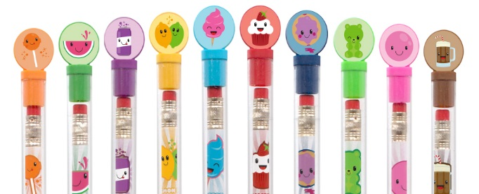

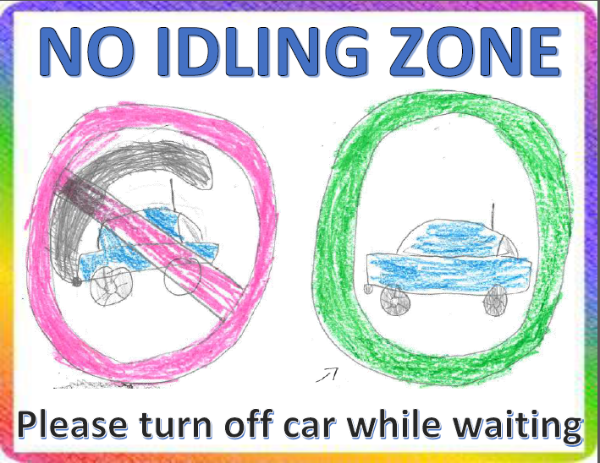
Fruitland Primary School is applying to become a Maryland Green School. Through this initiative, our students are learning to become better stewards of their local environment. Students in second grade created “Lights Out” posters to remind staff and students to turn classroom lights out when no one is in the room. Students in first grade created “No Idling” signs to be placed in the car rider loop to remind parents to turn their car engines off if they arrive early to pick up students. Jolie Zieger, from Mrs. Cadwallader’s class, won the “No Idling” poster contest as voted on by her peers. The winning sign can be seen to the left of this article.
Please look forward to additional ways that our students are recognizing their role as environmental stewards in the months ahead. In the months ahead, we look forward to sharing more examples of how our students are learning to become responsible stewards of our environment. During the PTA Spring Fair, we will celebrate our progress with games made from recyclable materials and exhibits featuring our on-going Green Schools initiatives. The school green team has also created a list of potential projects to be completed on school grounds in support of our Green School Application. After reviewing the list below, please contact school administration if you have the resources or skill set to help with any of the projects listed.
- Community Garden
- Outdoor Classroom
- Butterfly Garden
- Wildflower Meadow
- Schoolwide Recycling

It has been said that it takes a “village” to raise a child. With that philosophy, FPS is ONE school, ONE “village” where KINDNESS MATTERS. Our guidance office is in need of the following items as we ALL work together to support our students.
- Gently used clothing
- NEW socks and underwear
- Baby wipes

Art By:
Jolie Zieger
1st Grade
SMENCIL FRIDAYS
Our Fruitland PTA’s first SMENCIL Day was met with AMAZING success. It was so popular with our students that we sold out in a single Friday. We have decided to celebrate SMENCIL Friday on the third Friday of each month. This month’s SMENCIL Friday will be February 17th.
$1.00 each

Wyatt's Warriors Foundation was created to honor the memory of Wyatt and help families at a difficult time by providing comfort, support, education and encouragement. In order to fulfill this mission we have several objectives in mind. The Wyatt's Warriors Foundation strives to provide support to the community through events, assistance, education, and faith.
February is CHD Awareness month. Beginning February 13th and going through March 31st, Fruitland Primary will be collecting tabs to be donated to the Ronald McDonald House Charities of Greater Washington, D.C. Pop tabs will be recycled by RMH to earn money to support their program of easing the hardship of childhood illness on children and their families.
A Ronald McDonald House is a “home-away-from-home” for families so they can stay close by their hospitalized child at little or no cost.
Classrooms will be competing to collect the most pop tabs. The 1st place winner will receive yummy, gooey pizza, 2nd place will snack on delicious donuts, and 3rd place will enjoy extra recess.

Wyatt’s Warriors
Pop Tab Collection

1st Grade, Term 2 Academic Achievement – All A’s and B’s

Abhilash, Adithya
Agoglia, Adam James
Apolenis, Addison Hope
Bailey, Liam Joseph
Banks, Wyatt Mitchell
Bessa, Luisa Morais
Black, Connor Jacob
Borck, Serenity Nicole
Bounds, Noah Christopher
Boyd, Alyssa Lynn
Briggs, Owen Patrick
Bright, Julia Anne
Brown, Shane Miller
Burkett, Ella Mae Page
Charlton, Logan Giles
Clark, Derrick Lamont Jr
Combs, Isabella Nicole
Correa, Jamiyah A'Shay
Croswell, Harlem Ja'Karee
Da Silva, Micaella Albuquerque
Darrigo, Leo Anthony
Davis, Mason Kent
Dees, Nathanael Braxton
Dellies, Jackson Jeffrey
Duncan, William George
Dunlevy, Bryce Daniel
Edmonds, Shelly Maranda
Fadl, Panseah Ahmed Mohamed
Felton, Edwin Tyrone II
Fetters, Kayden Wayne
Foltz, Thomas Robert
Foreman, Kenedi Lanae' Bakor
Giles, Ethan Kelly
Goris, Lillian Virginia Elaine
Green, Paxton Richard
Gregory, Brooklynn Lee
Harris, Elijiah Chad
Hearn, Jacob Alexander
Hernandez, Savannah Victoria
Howard, Charley Alexis
Hulse, Taylor Ann
Hurley, Kaitlyn Grace
Jimmerson, Macaulley Edward
Johnson, Alexandra Della Rain
Johnston, Chase Oliver
Jones, Joseph Harris IV
Kearns, John Stewart III
Kellam, Isabella Nicole
Kim, Rachel Seung Yeon
King, Kayce Marie
Koerner, Christopher Ryan
Kresge, Lila Kate
Ladd, Ian Michael
Leager, Kimberly Ellen
Lee, Mackenzie Anne
Lieb, Alexandra Rose
Martir-Garcia, Dubraska Michelle
McCary, Addison Grace
McDermott, Gabrielle Johannah
McDermott, Rooney Catherine
McIntyre, Logan John
McKeithan, Aaliyah Bri'elle
Morandi, Lena Maren
Moss, De'Asia Janeen
Murphy, Wyatt Liam
Murray, Seniya Renae'
Ommer, Saifullah
O'Shield, Aiden James
Park, Samuel Isaac
Parker, Abbigale Faith
Perdue, Addison Renee
Phillips, Samantha Grace
Powell, Bentley Ryan
Price, Emily Charlotte
Putman, David Avery
Rathel, Carson Colby
Rayfield, Emmett Eli
Rayfield, Joshua Douglas
Rhoat, Samuel Nelson
Rhock, Daivon Monroe
Schultheis, Benjamin Ryan
Senter, Cooper Wayne
Sheats, Gideon Luke
Shipley, Gavin Charles
Skelton, Makenzie Skye
Smith, Benjamin Jacob
Soto, Olivia Ade'lakaye
Staab, Michael Frederick
Staffeldt, Dylan Jacob
Stuart, John Scott
Swanson, Liam Jacob
Swift, Alex Thomas
Todd, Robert Allen Jr
Truitt, Olivia Danielle
Twilley, Ella Elizabeth
Urban, Cooper Chase
Valenzano, Luca Chase
Whayland, Trenton Matthew
Williams, Cody Michael
Womack, Rayana Janell
Young, Demantay Ashan
Yurek, Zoe Olivia
Zieger, Jolie Rose

Adkins, Brianna Grace
Anderson, Delia Lauren
Appleby, Marlie Adyson
Asif, Javeria
Ball, Connor Lloyd
Bate, Miriam Rose
Bleile, Madyson Elizabeth
Bounds, Cheyenne Renee
Bratten, Hallie Dawn
Bratten-Jones, K'mora London
Bravo, Anaya Tamar
Bryant, Love Salome
Buckingham, Sadie Rose
Burch, Benton Xavier
Burgmann, Petra
Chelton, Haven Elizabeth
Chen, Shannon
Contreras, Cameron Wesley
Cook, Gabrielle Lynn
Croyle, Jackson Taylor
Davis, Kendall McKenna
Derbyshire, Landon Avery
DeWeerdt, Hope Addison
Dryden, Regan Leigh
Dunn, Madison Elizabeth
Eby, Aubrey Mae
Emge, Kendal Elizabeth
Ferrand, Chance Everett
Gill, Harjot Singh
Goodyear, Lily Jane
Gormley, Thomas John
Halcott, Lilah Rose
Hammond, Kylie Ann
Harkins, Canie Beatrice
Hill, Logan Wesley
Horner, Laila Carsyn
Howard, Sommer Grace
Joseph, Jackson Rylee
Kostelac, Juliette Ava
Kushyk, Jake Joseph
Lima-Melo, Daniel Junior
Lowe, Noah Michael
Magaha, Olivia Grace
Martinetti, Guiliana Gabriela
Messick, Jeremy Aidan
Niblett, Gunner Kane
Nichols, Isaac Chad
Orneus, Merlina Sephora
Ospital, Holden Rock
Parrott, Peyton Christopher
Phillips, Emma Gianna Marie
Pulcher, Charles Thomas
Rhoat, Jackson Hartley
Ricketts, Emma Claire
Robinson, Faith Margaret
Sachs, Derek Christopher
Sanchez-Ponce, Stephanie
Schoolfield, Daniyah LaNay
Shepherd, Onnica Jean
Shipe, Julianna Marilyn
Simmons, Robert Wayne
Slade, Max
Slovikosky, Lillian Kate
Sterling, Amber Kathleen
Streng, Reagan Brooke
Swanson, Lukas Oliver
Swenson, Lucas Arnel
Tawes, Avery Charles Franklin
Taylor, Owen Phillip
Tayman, Shannon Louise
Tully, Gemma Brynn
Watson, Bailey Morgan
Webster, Caleb Lee
Wheeler, Madison Paige
Wilkins, Alyssa Marie
Will, Peyton Shae
Wilson, Tessa Marie
Yamakawa, Jonathan Kinuemon
Yurek, Ethan Aaron
2nd Grade, Term 2 Academic Achievement – All A’s and B’s

